House Price Prediction – Regression
Submitted in partial fulfillment of the requirements
of the degree
BACHELOR OF ENGINEERING IN ARTIFICIAL INTELLIGENCE & DATA SCIENCE ENGINEERING
By
Dipti Patil - Roll No. 57
Ishwari Mane - Roll No. 52
Akshata Mishra - Roll No. 53
Manali Madhavi - Roll No. 48
Poorva Kharade - Roll No. 43

Department of Artificial Intelligence & Data Science Engineering
A.C.Patil College of Engineering
Kharghar, Navi Mumbai
University of Mumbai
(AY 2026-27)

CERTIFICATE
This is to certify that the Mini Project - 2B entitled “ House Price Prediction – Regression ” is a bonafide work of Dipti Patil (57), Ishwari Mane (52), Akshata Mishra (53), Manali Madhavi (48) and Poorva Kharade (43) submitted to the University of Mumbai in partial fulfillment of the requirement for the award of the degree of “Bachelor of Engineering” in “Artificial Intelligence & Data Science Engineering” .
(Prof.Sanjana Mahadik )
Mentor
(Prof.S.P.Bansu )  Head of Department | (Dr.S.R.Deore )  Principal

Mini Project Approval
This Mini Project - 2B entitled “House Price Prediction – Regression” by Dipti Patil (57), Ishwari Mane (52), Akshata Mishra (53), Manali Madhavi (48) and Poorva Kharade (43) is approved for the degree of Bachelor of Engineering in Artificial Intelligence & Data Science Engineering.
Date:
Place:Kharghar

Contents
Abstract ii
Acknowledgments iii
List of Abbreviations iv
List of Figures v
List of Tables vi
List of Symbols vii
1 Introduction 1
1.1 Introduction 1
1.2 Motivation 1
1.3 Problem Statement & Objectives 1
1.4 Organization of the Report 2
2 Literature Survey 3
2.1 Survey of Existing System 3
2.2 Limitation of Existing System or Research Gap 3
2.3 Mini Project Contribution 4
3 Proposed System (House Price Prediction using Machine Learning) 5
3.1 Introduction 5
3.2 Architecture/ Framework 5
3.3 Algorithm and Process Design 6
3.4 Details of Hardware & Software 7
3.5 Code 8
3.6 Experiment and Results 9
3.7 Conclusion and Future Work 14
References 15

Abstract
The price of a house depends on many factors such as the income of the neighbourhood, the age of the houses, the number of rooms, the population density and the geographic location. Estimating prices manually is slow and inconsistent. This mini project treats house price prediction as a supervised regression problem and uses machine learning to predict the median house value of a California housing district from census-based features.
The project uses the California Housing dataset (1990 U.S. Census) containing 20,640 districts, 8 input features and one target, MedHouseVal. Exploratory data analysis was performed to check missing values, duplicates, outliers, the distribution of the target and the correlation between the features. The data was pre-processed by removing duplicates, adding the engineered feature BedroomRatio, median imputation, clipping of every feature to its 1st–99th percentile and standard scaling, and was divided into 80% training and 20% testing data.
A baseline Linear Regression model was compared with a Random Forest Regressor. On the unseen test set the Random Forest achieved R² = 0.8052, MAE = 0.3275 (about $32,750) and RMSE = 0.5052 (about $50,520), clearly outperforming Linear Regression (R² = 0.6655). The 5-fold cross-validation R² of 0.8041 is almost the same as the test R², which shows that the model is stable. Feature-importance analysis shows that median income is the dominant factor, followed by household occupancy and the location (latitude and longitude).
Keywords: House price prediction, regression, Random Forest, Linear Regression, California Housing, feature importance.

Acknowledgments
We would like to express our sincere gratitude to our mentor, Prof. Sanjana Mahadik, for the valuable guidance, constant encouragement and support throughout the work on this mini project. Her/his suggestions helped us to understand the subject and to complete the project successfully.
We are thankful to the Head of the Department of Artificial Intelligence & Data Science Engineering, Prof. S.P.Bansu, and to the Principal of A. C. Patil College of Engineering, Kharghar, Dr.S.R.Deore, for providing the facilities and a supportive environment for our work.
We also thank all the teaching and non-teaching staff of the department, the authors of the dataset and of the open-source libraries used in this project, and our families and friends for their support.
Dipti Patil (57)
Ishwari Mane (52)
Akshata Mishra (53)
Manali Madhavi (48)
Poorva Kharade (43)

List of Abbreviations
Abbreviation | Full Form
AI | Artificial Intelligence
AY | Academic Year
CV | Cross-Validation
EDA | Exploratory Data Analysis
LR | Linear Regression
MAE | Mean Absolute Error
ML | Machine Learning
MSE | Mean Squared Error
PRN | Permanent Registration Number
R² | Coefficient of Determination
RF | Random Forest
RMSE | Root Mean Squared Error
SMLDS | Statistical Machine Learning for Data Science

List of Figures
Figure 3.1 Project workflow of the proposed system 6
Figure 3.2 Distribution of median house value (target variable) 10
Figure 3.3 Correlation heatmap of all features and the target 10
Figure 3.4 Median income versus median house value (hexbin density plot) 11
Figure 3.5 Actual versus predicted house values (Random Forest, test set) 12
Figure 3.6 Feature importance of the Random Forest model 13

List of Tables
Table 3.1 Input features of the California Housing dataset 5
Table 3.2 Hardware and software details 7
Table 3.3 Results of the models on the test set 11

List of Symbols
Symbol | Meaning
y | Actual (true) median house value
ŷ | Predicted median house value
ȳ | Mean of the actual values
n | Number of samples
Σ | Summation
|·| | Absolute value
k | Number of cross-validation folds (k = 5)
β | Coefficients (weights) of the Linear Regression model
x | Input feature vector
μ, σ | Mean and standard deviation used in standard scaling

1 Introduction

1.1 Introduction
Housing is one of the largest financial decisions in a person’s life, and the price of a house is influenced by many factors such as the income of the people living nearby, the age and size of the houses, the population density and the location. Buyers, sellers, banks and government agencies all need a reliable estimate of the value of a property. Traditionally, such estimates are prepared manually by experts, which is slow, costly and subjective.
Machine learning can learn the relationship between the characteristics of a property or a locality and its price directly from historical data. When the quantity to be predicted is a continuous number, such as a price, the task is called regression. In this mini project, regression models are trained on the California Housing dataset to predict the median house value of a district, and their performance is evaluated on data that was not used for training.

1.2 Motivation
- Manual valuation of houses is time-consuming and may differ from one person to another; a data-driven model gives consistent and quick estimates.
- Housing prices are affected by many interacting factors, and it is difficult to judge the effect of each factor without analysing data.
- Comparing a simple model (Linear Regression) with a more powerful model (Random Forest) shows when non-linear models are really needed.
- The project gives practical experience of the complete data-science workflow: data exploration, pre-processing, model building, evaluation and interpretation.

1.3 Problem Statement & Objectives
Problem Statement
Given census-based characteristics of a California housing district (median income, house age, average rooms, average bedrooms, population, average occupancy, latitude and longitude), predict the median house value of that district using machine learning. This is a supervised regression problem.
Scope
The project is an educational data-science study based on the 1990 California census data. It predicts district-level median house values, not the price of an individual house, and it does not use live market data. Real prices also depend on factors that are absent from the dataset, such as the condition of the house, the size of the plot, school quality and current market demand.
Objectives
- To define house price prediction as a regression problem and select a suitable public dataset.
- To perform exploratory data analysis (EDA) to check missing values, duplicates and important patterns in the data.
- To pre-process the data and divide it into training (80%) and testing (20%) sets.
- To train and compare a baseline Linear Regression model with a Random Forest Regressor.
- To evaluate the models on unseen data using MAE, RMSE and R², and to confirm stability with 5-fold cross-validation.
- To identify which features influence house prices the most.

1.4 Organization of the Report
The report is organized into three chapters.
- Chapter 1 – Introduction: gives the background, motivation, problem statement, scope and objectives of the project.
- Chapter 2 – Literature Survey: reviews existing work on house price prediction, points out the limitations of existing approaches and states the contribution of this mini project.
- Chapter 3 – Proposed System: describes the dataset, the architecture of the system, the algorithms and process design, the hardware and software used, the code, the experiments and results, and the conclusion with future work.
The report ends with the list of references.

2 Literature Survey

2.1 Survey of Existing System
Early work on house price modelling used the hedonic pricing approach, in which the price of a house is explained as a combination of the values of its characteristics. Harrison and Rubinfeld (1978) applied a hedonic regression to housing data of the Boston area to estimate the demand for clean air, and this dataset has since become a standard benchmark for regression [2]. Linear models of this kind are simple and easy to interpret, because each coefficient shows the effect of one feature on the price, but they assume that the features act independently and in a straight-line manner [4].
Pace and Barry (1997) built the California Housing dataset from the 1990 U.S. Census and used it to study sparse spatial autoregressions. Their work showed that the location of a district strongly influences house values, because neighbouring districts tend to have similar prices [1]. The dataset is now distributed with the scikit-learn library and is widely used to teach and to compare regression methods [3].
Ensemble methods have become popular for price prediction. The Random Forest algorithm of Breiman (2001) trains many decision trees on random samples of the data and averages their predictions, which reduces over-fitting and allows non-linear relationships and feature interactions to be captured without much tuning [5]. Gradient-boosted trees, such as XGBoost, are another widely used family of models that often give very high accuracy on tabular data [6]. Hastie, Tibshirani and Friedman (2009) give a detailed treatment of linear models, tree-based methods, cross-validation and model assessment, which forms the basis of the methodology followed in this project [4].

2.2 Limitation of Existing System or Research Gap
- Manual and purely hedonic (linear) valuation cannot represent the non-linear effect of location, in which latitude and longitude act together rather than independently.
- Linear models are affected by strongly correlated features (multicollinearity) and by extreme values, which are common in census data.
- Many simple demonstrations train a model without checking data quality, handling outliers or using cross-validation, so the reported accuracy may not be reliable.
- Pre-processing steps such as outlier limits and imputation are sometimes calculated on the complete dataset, which leaks information from the test data into the model.
- The effect of capping (censoring) of the target variable at $500,000 in the California data is often ignored when results are discussed.

2.3 Mini Project Contribution
- A complete and reproducible regression workflow is implemented: dataset → EDA → pre-processing → train/test split → ML model → evaluation → results → conclusion.
- A thorough data-quality check is carried out, and outliers are limited by clipping every feature to its 1st–99th percentile, using limits calculated only from the training data to avoid data leakage.
- A new feature, BedroomRatio, is engineered from the existing features.
- A baseline Linear Regression model is compared with a Random Forest Regressor using MAE, RMSE, R² and 5-fold cross-validation.
- The model is interpreted by feature-importance analysis, and the effect of the capped target on the predictions is explained.

3 Proposed System (House Price Prediction using Machine Learning)

3.1 Introduction
The proposed system is a machine-learning pipeline that predicts the median house value of a California district from census features. The project uses the California Housing dataset, which is based on the 1990 U.S. Census. Each row describes one census block group (a “district”). The data is loaded in Python using sklearn.datasets.fetch_california_housing. It has 20,640 rows and 9 columns (8 input features and 1 target).
Dataset source: Pace, R. K. and Barry, R. (1997). Sparse Spatial Autoregressions. Statistics & Probability Letters, 33, 291–297. Accessed through scikit-learn: https://scikit-learn.org/stable/modules/generated/sklearn.datasets.fetch_california_housing.html
Target variable
The target is MedHouseVal, the median house value of the district, expressed in units of $100,000 (for example, 2.0 means $200,000).
Input features
Table 3.1: Input features of the California Housing dataset
Feature | Description
MedInc | Median household income in the district (in $10,000s)
HouseAge | Median age of houses in the district (years)
AveRooms | Average number of rooms per household
AveBedrms | Average number of bedrooms per household
Population | Number of residents in the district
AveOccup | Average number of household members
Latitude | Latitude of the district
Longitude | Longitude of the district

3.2 Architecture/ Framework
The system follows a sequential pipeline. The California Housing data is first explored (EDA) and then pre-processed. The cleaned data is divided into training and testing sets, the two models are trained on the training set, and the trained models are evaluated on the unseen test set. The results are then analysed to select the best model and to find the most important features. The workflow is shown in Figure 3.1.
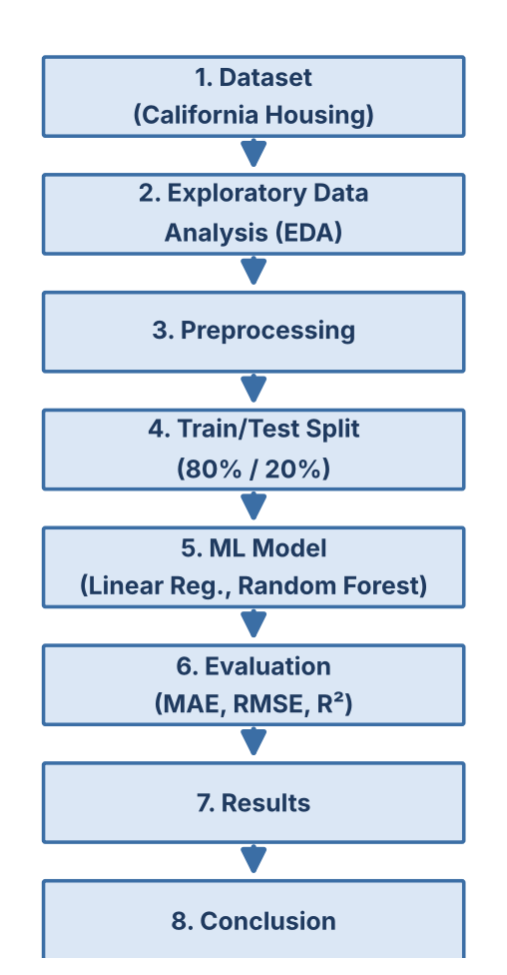
Figure 3.1: Project workflow – Dataset → EDA → Preprocessing → Train/Test Split → ML Model → Evaluation → Results → Conclusion.

3.3 Algorithm and Process Design
Process steps
- Load the California Housing dataset.
- Perform EDA: check missing values, duplicates, distributions and correlations.
- Pre-process: remove duplicates, add BedroomRatio, impute, clip outliers and scale.
- Split the data into 80% training and 20% testing data.
- Train both models on the training data; use 5-fold cross-validation on the training set.
- Predict house values for the test set and calculate MAE, RMSE and R².
- Select the best model and analyse the feature importance.
Data pre-processing
- Cleaning: duplicate rows are removed using drop_duplicates (none were found). Missing values are handled with a median imputer fitted on the training data only; the dataset has no missing values, but the step keeps the pipeline robust.
- Feature engineering: one new feature, BedroomRatio = AveBedrms / AveRooms, is added to represent the share of bedrooms among all rooms. After this step the models use 9 input features.
- Outliers: every feature is clipped to its 1st–99th percentile to limit the effect of extreme values such as AveRooms = 141.9 and AveOccup = 1,243. The limits are calculated from the training data only and then applied to the test data, which avoids data leakage.
- Scaling: StandardScaler (z = (x − μ) / σ) is applied for Linear Regression, because it is sensitive to feature scale. Random Forest does not require scaling.
- Train/test split: 80% training data (16,512 rows) and 20% testing data (4,128 rows) with random_state = 42 for reproducibility. The test set is kept unseen until the final evaluation.
Algorithms
- Linear Regression (baseline): models the price as a weighted sum of the features, ŷ = β₀ + β₁x₁ + … + βₚxₚ. The coefficients are found by minimising the sum of squared errors. It is simple and fast but assumes a linear relationship.
- Random Forest Regressor (main model): an ensemble of 200 decision trees (min_samples_leaf = 2). Each tree is trained on a random bootstrap sample of the training data and a random subset of features is considered at each split; the final prediction is the average of the predictions of all trees. It can capture non-linear relationships and interactions, such as the effect of location, without needing feature scaling.
Evaluation metrics
- MAE (Mean Absolute Error): MAE = (1/n) Σ |y − ŷ|; the average absolute difference between actual and predicted values, easy to interpret in dollars.
- RMSE (Root Mean Squared Error): RMSE = √[(1/n) Σ (y − ŷ)²]; it penalises large errors more strongly than MAE.
- R² (coefficient of determination): R² = 1 − Σ(y − ŷ)² / Σ(y − ȳ)²; the share of the variance in house value explained by the model; closer to 1 is better.
- CV R²: the mean R² from 5-fold cross-validation on the training data, which shows whether the result is stable.

3.4 Details of Hardware & Software
Table 3.2: Hardware and software details
Component | Details
Hardware | Personal computer / laptop with a multi-core processor and 8 GB RAM (recommended); no GPU is required
Operating system | Windows / Linux / macOS
Programming language | Python 3
Libraries | NumPy, Pandas, Matplotlib, Seaborn, Scikit-learn
Dataset access | sklearn.datasets.fetch_california_housing
Development environment | Jupyter Notebook / Google Colab / any Python IDE

3.5 Code
The complete Python code of the project is given below (house_price_prediction.py).
"""House Price Prediction - Regression (California Housing, 1990 Census)."""
import numpy as np
import pandas as pd
import matplotlib.pyplot as plt
import seaborn as sns
from sklearn.datasets import fetch_california_housing
from sklearn.model_selection import train_test_split, cross_val_score
from sklearn.impute import SimpleImputer
from sklearn.preprocessing import StandardScaler
from sklearn.linear_model import LinearRegression
from sklearn.ensemble import RandomForestRegressor
from sklearn.metrics import mean_absolute_error, mean_squared_error, r2_score

# ---------------- 1. Load dataset ----------------
data = fetch_california_housing(as_frame=True)
df = data.frame # 20,640 rows x 9 columns
print(df.shape, df.isnull().sum().sum(), df.duplicated().sum())
print(df.describe().T)

# ---------------- 2. Exploratory Data Analysis ----------------
plt.figure(figsize=(7, 4))
sns.histplot(df["MedHouseVal"], bins=50, kde=True)
plt.title("Distribution of Median House Value")
plt.savefig("fig_target_distribution.png", dpi=150)

plt.figure(figsize=(8, 6))
sns.heatmap(df.corr(), annot=True, fmt=".2f", cmap="coolwarm")
plt.title("Correlation Heatmap")
plt.savefig("fig_correlation.png", dpi=150)

plt.figure(figsize=(7, 5))
plt.hexbin(df["MedInc"], df["MedHouseVal"], gridsize=40, cmap="viridis", bins="log")
plt.xlabel("MedInc"); plt.ylabel("MedHouseVal")
plt.savefig("fig_income_vs_value.png", dpi=150)

# ---------------- 3. Pre-processing ----------------
df = df.drop_duplicates()
df["BedroomRatio"] = df["AveBedrms"] / df["AveRooms"] # feature engineering

X = df.drop(columns="MedHouseVal")
y = df["MedHouseVal"]
X_train, X_test, y_train, y_test = train_test_split(
X, y, test_size=0.20, random_state=42) # 16,512 / 4,128

imputer = SimpleImputer(strategy="median").fit(X_train) # fitted on train only
X_train = pd.DataFrame(imputer.transform(X_train), columns=X.columns)
X_test = pd.DataFrame(imputer.transform(X_test), columns=X.columns)

low, high = X_train.quantile(0.01), X_train.quantile(0.99) # limits from train only
X_train = X_train.clip(low, high, axis=1)
X_test = X_test.clip(low, high, axis=1)

scaler = StandardScaler().fit(X_train) # used for Linear Regression
X_train_s, X_test_s = scaler.transform(X_train), scaler.transform(X_test)

# ---------------- 4. Model building ----------------
lin = LinearRegression()
rf = RandomForestRegressor(n_estimators=200, min_samples_leaf=2,
random_state=42, n_jobs=-1)

lin_cv = cross_val_score(lin, X_train_s, y_train, cv=5, scoring="r2").mean()
rf_cv = cross_val_score(rf, X_train, y_train, cv=5, scoring="r2").mean()

lin.fit(X_train_s, y_train)
rf.fit(X_train, y_train)

# ---------------- 5. Evaluation ----------------
def evaluate(name, model, Xt, cv_r2):
pred = model.predict(Xt)
mae = mean_absolute_error(y_test, pred)
rmse = np.sqrt(mean_squared_error(y_test, pred))
r2 = r2_score(y_test, pred)
print(f"{name:18s} MAE={mae:.4f} RMSE={rmse:.4f} R2={r2:.4f} CV R2={cv_r2:.4f}")
return pred

evaluate("Linear Regression", lin, X_test_s, lin_cv)
rf_pred = evaluate("Random Forest", rf, X_test, rf_cv)

# ---------------- 6. Result plots ----------------
plt.figure(figsize=(6, 6))
plt.scatter(y_test, rf_pred, s=6, alpha=0.4)
plt.plot([0, 5], [0, 5], "r--")
plt.xlabel("Actual"); plt.ylabel("Predicted")
plt.title("Actual vs Predicted (Random Forest)")
plt.savefig("fig_actual_vs_predicted.png", dpi=150)

imp = pd.Series(rf.feature_importances_, index=X.columns).sort_values()
plt.figure(figsize=(7, 5))
imp.plot(kind="barh")
plt.title("Feature Importance (Random Forest)")
plt.tight_layout()
plt.savefig("fig_feature_importance.png", dpi=150)

3.6 Experiment and Results
Data quality checks
- Shape of the data: 20,640 rows × 9 columns; all columns are numeric.
- Missing values: 0 in every column. Duplicate rows: 0.
- Summary statistics show some extreme values: AveRooms reaches 141.9, AveOccup reaches 1,243 and Population reaches 35,682, while their medians are 5.2, 2.8 and 1,166. These are outliers and are treated during pre-processing.
- The target has mean 2.07, median 1.80 and maximum 5.00, with a skewness of 0.98 (right-skewed).
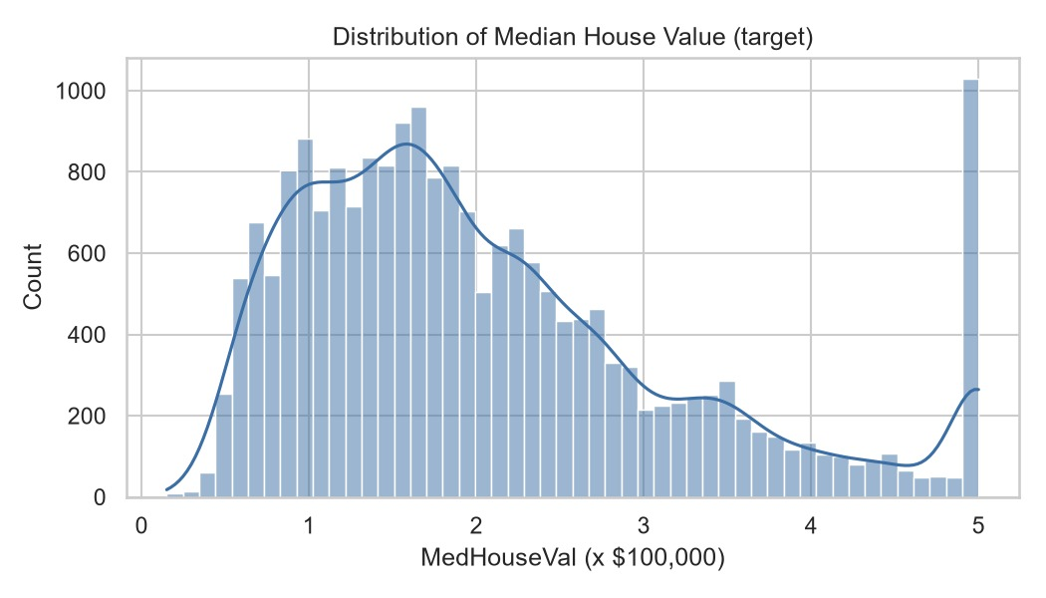
Figure 3.2: Distribution of median house value (target variable).
Observation: Most districts have a median house value between about 0.5 and 3 (i.e., $50,000–$300,000), with the peak near 1.5–1.8. The distribution is right-skewed, so there are fewer expensive districts. A sharp spike appears at exactly 5.0 (about 4.7% of districts), which shows that the target was capped (censored) at $500,000 in the original data. Prices above this value are therefore not represented correctly.
Correlation between features
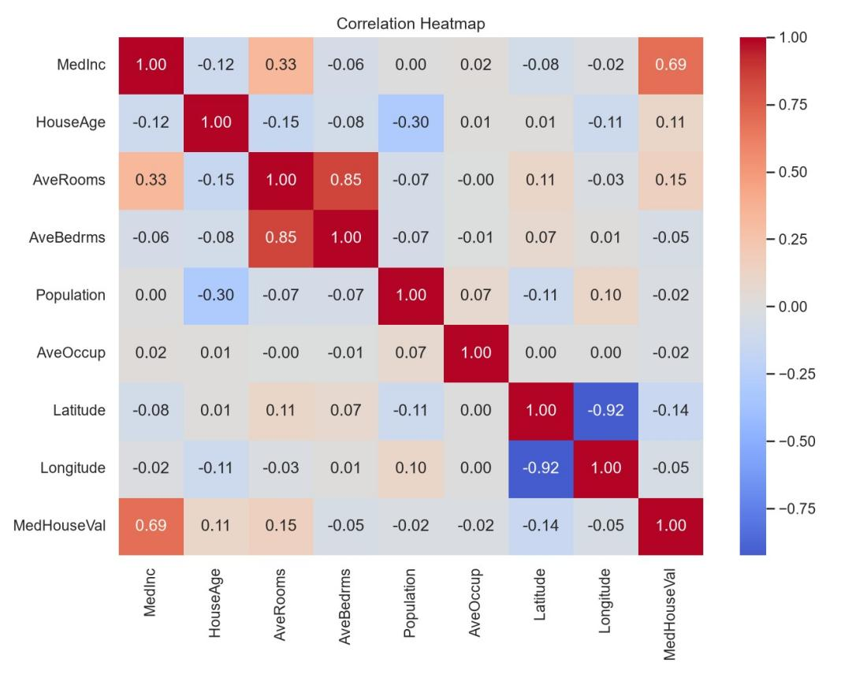
Figure 3.3: Correlation heatmap of all features and the target.
Observation: Median income (MedInc) has the strongest positive correlation with house value (+0.69). AveRooms (+0.15), HouseAge (+0.11) and Latitude (−0.14) show only weak relationships. AveRooms and AveBedrms are strongly correlated with each other (0.85), and Latitude and Longitude are strongly negatively correlated (−0.92) because of the shape of California; these relationships are examples of multicollinearity, which can affect linear models more than tree-based models.
Strongest predictor versus house value
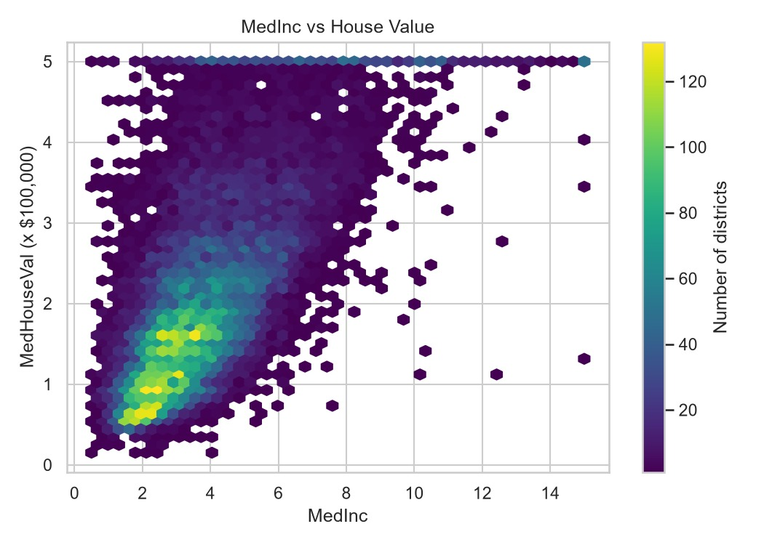
Figure 3.4: Median income versus median house value (hexbin density plot).
Observation: House value generally increases as median income increases, and most districts are concentrated at lower incomes (2–5) and values (0.5–2.5). The horizontal line at 5.0 again shows the price cap. The spread of prices becomes wider at higher incomes, so income alone cannot predict price exactly, and other features such as location are also needed.
Model results
Both models were evaluated on the unseen test set (4,128 districts). MAE and RMSE are in units of $100,000.
Table 3.3: Results of the models on the test set
Model | MAE | RMSE | R² | CV R² (mean)
Linear Regression (baseline) | 0.4808 | 0.6621 | 0.6655 | 0.6861
Random Forest Regressor | 0.3275 | 0.5052 | 0.8052 | 0.8041

For the Random Forest, MAE = 0.3275 corresponds to an average error of about $32,750, and RMSE = 0.5052 corresponds to about $50,520.
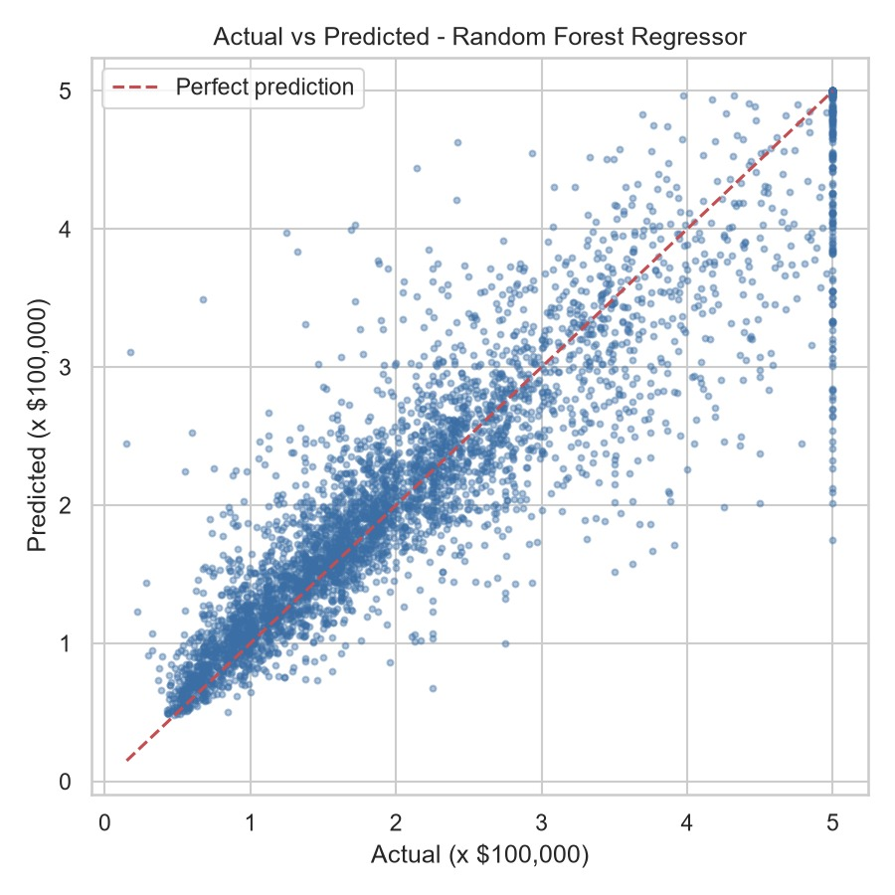
Figure 3.5: Actual versus predicted house values for the Random Forest Regressor (test set).
Observation: Most points lie close to the red dashed line (perfect prediction), which means that the predictions are generally close to the actual values. The spread increases for expensive districts, where the model tends to under-predict. The vertical column of points at an actual value of 5.0 is caused by the capped target: the true value is cut off at 5.0 while the model predicts a range of values below it.
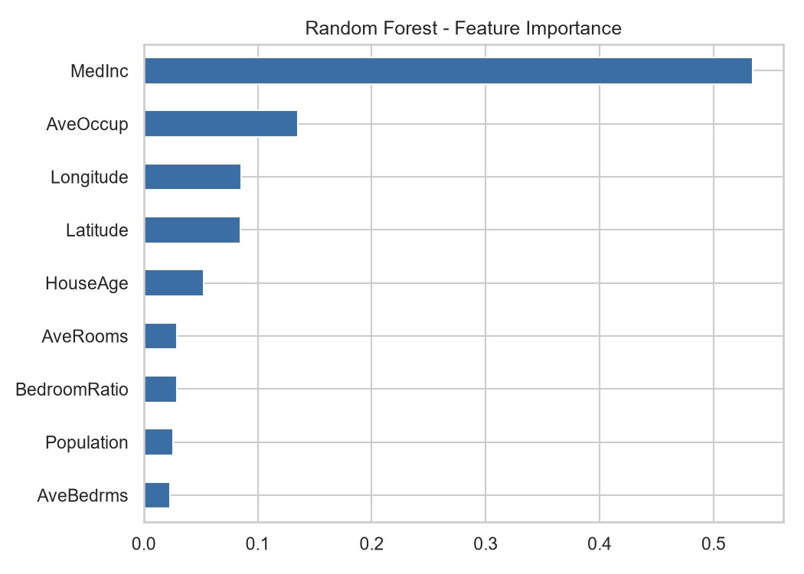
Figure 3.6: Feature importance of the Random Forest model.
Observation: Median income (MedInc) is by far the most important feature (about 0.53). AveOccup (about 0.14), Longitude and Latitude (about 0.09 each) follow, and HouseAge comes next. Rooms, BedroomRatio, Population and AveBedrms contribute little. This agrees with the correlation analysis, and the importance of Latitude and Longitude shows that location is a major price factor.
Discussion
The Random Forest Regressor is the best model. On the unseen test set it achieved R² = 0.8052, so it explains about 80.5% of the variance in house values, compared with 66.6% for Linear Regression. Its MAE of 0.3275 (about $32,750) is lower than the 0.4808 of the baseline, and its RMSE of 0.5052 is lower than 0.6621. The cross-validation R² of the Random Forest (0.8041) is almost the same as the test R² (0.8052), which suggests that the model is stable and not overfitted to a single split.
The improvement over Linear Regression shows that the relationship between the features and price is non-linear. For example, the effect of location depends on both latitude and longitude together, which a straight-line model cannot represent well. The feature-importance analysis shows that median income is the dominant factor, followed by household occupancy and location. The model is useful for approximate estimates, but it is not exact: the error grows for high-priced districts, and the capping of the target at 5.0 limits the accuracy for the most expensive areas.

3.7 Conclusion and Future Work
Conclusion
This project built a house price prediction system using the California Housing dataset, following the workflow Dataset → EDA → Preprocessing → Train/Test Split → ML Model → Evaluation → Results → Conclusion. The data had no missing values or duplicates, and outliers were handled by percentile clipping. The Random Forest Regressor performed best, with R² = 0.8052, MAE = 0.3275 (about $32,750) and RMSE = 0.5052 (about $50,520) on the test set, clearly outperforming the Linear Regression baseline (R² = 0.6655). Median income and location were found to be the most important factors affecting house prices.
Limitations
- The data is from the 1990 census and does not reflect current prices.
- The target is capped at $500,000, so the most expensive districts are not represented correctly.
- Predictions are for district-level medians, not individual houses; house condition, size and neighbourhood quality are not included.
- The Random Forest was not hyperparameter-tuned, and only two models were compared.
Future Work
- Tune the hyperparameters with GridSearchCV.
- Try Gradient Boosting or XGBoost.
- Add location-based features, for example the distance to the coast or to major cities.
- Use more recent data so that the model reflects current prices.

References
[1] Pace, R. K. and Barry, R. (1997). Sparse Spatial Autoregressions. Statistics & Probability Letters, 33(3), 291–297. (California Housing dataset, 1990 U.S. Census.)
[2] Harrison, D. and Rubinfeld, D. L. (1978). Hedonic Housing Prices and the Demand for Clean Air. Journal of Environmental Economics and Management, 5(1), 81–102.
[3] Pedregosa, F. et al. (2011). Scikit-learn: Machine Learning in Python. Journal of Machine Learning Research, 12, 2825–2830. Dataset page: https://scikit-learn.org/stable/modules/generated/sklearn.datasets.fetch_california_housing.html
[4] Hastie, T., Tibshirani, R. and Friedman, J. (2009). The Elements of Statistical Learning: Data Mining, Inference, and Prediction, 2nd ed. Springer.
[5] Breiman, L. (2001). Random Forests. Machine Learning, 45(1), 5–32.
[6] Chen, T. and Guestrin, C. (2016). XGBoost: A Scalable Tree Boosting System. Proceedings of the 22nd ACM SIGKDD International Conference on Knowledge Discovery and Data Mining, 785–794.
[7] Pandas documentation: https://pandas.pydata.org/
[8] Matplotlib and Seaborn documentation: https://matplotlib.org/ and https://seaborn.pydata.org/
[9] Project code: house_price_prediction.py (supplied in house_price_project.zip).

